Milk Tea shop Management system

Brewster’s Cup / Joanlyn Butiong

Submitted by:

Firmante, Vincent C.
Dimayuga, Kristine Joy M.
Mayari, Diana Lyn

BSIT - 2202

Table of Contents

I. System Overview …………………………………… 3
II. Business Proposal …………………………………. 3
III. Introduction ………………………………………. 3
IV. Objectives …………………………………………. 4
V. Data Sources and Preparations ………………… 4-8
VI. Screenshots ……………………………………. 8-13
VII. Insights ………………………………………….. 13
VIII. Challenges and Learning ……………………... 14
IX. SQL Query Used …………………………….. 14-16

- System Overview

The Brewster’s Cup Management System is a desktop application developed in Python using the CustomTkinter GUI framework and a MySQL relational database for persistent storage. It provides comprehensive management capabilities for a milk tea shop, covering point-of-sale transactions, menu management, inventory tracking, employee records, attendance logging, promotional campaigns, expense recording, sales reporting, and system-wide activity and error logging. The system enforces role-based access control so that Admins, Managers, Cashiers, and Baristas each see only the modules relevant to their responsibilities. An automatic session timeout of 10 minutes logs out idle users to maintain security.

- Business Problem

Small milk tea shops in the Philippines commonly rely on manual order-taking, handwritten inventory counts, and paper-based payroll records. This approach leads to order inaccuracies, inventory stockouts, unreliable employee hour tracking, and a lack of consolidated sales insight that management can act upon. Without a unified system, reconciling daily sales against inventory consumed and expenses paid is slow and error-prone.

The Brewster’s Cup Management System addresses these problems by centralizing all operational data in a single MySQL database, automating inventory deduction upon order completion via database triggers, providing role-filtered dashboards, and generating on-demand sales and expense reports so that management can make timely, data-driven decisions.

- Introduction

Brewster’s Cup is a milk tea shop located in Lian, Batangas, Philippines, that offers a wide selection of milk teas, fruit teas, coffees, and specialty drinks in multiple sizes with customizable sugar levels, ice levels, and add-on toppings. As the shop expanded its menu and customer base, the existing manual procedures for taking orders, tracking ingredients, and managing staff became increasingly difficult to sustain, prompting the need for a purpose-built management system.

The project was conceived to replace fragmented spreadsheets and paper records with a single, integrated desktop application accessible on a Windows machine at the shop counter. The system was designed with simplicity in mind so that non-technical staff can operate it after minimal training, while still providing Admins and Managers with the analytical tools they need to monitor performance and control costs.

- Objectives

- Provide a point-of-sale (POS) interface that allows cashiers to process orders, apply promotions, and accept multiple payment methods quickly and accurately.
- Automate inventory deduction each time an order is placed, using ingredient recipes stored in the database, so that stock levels are always current.
- Enforce role-based access control so that system sections and data-editing capabilities are granted only to users whose role requires them.
- Track employee attendance with Time In and Time Out logs and surface per-employee attendance summaries for payroll computation.
- Generate consolidated sales, expense, and inventory reports to support management decision-making without manual data aggregation.
- Record all significant user actions and system errors in append-only audit logs to support accountability and troubleshooting.
- Implement a session timeout mechanism that automatically logs out inactive users to protect sensitive business data.

- Data Sources and Preparation

Case Study Diagram

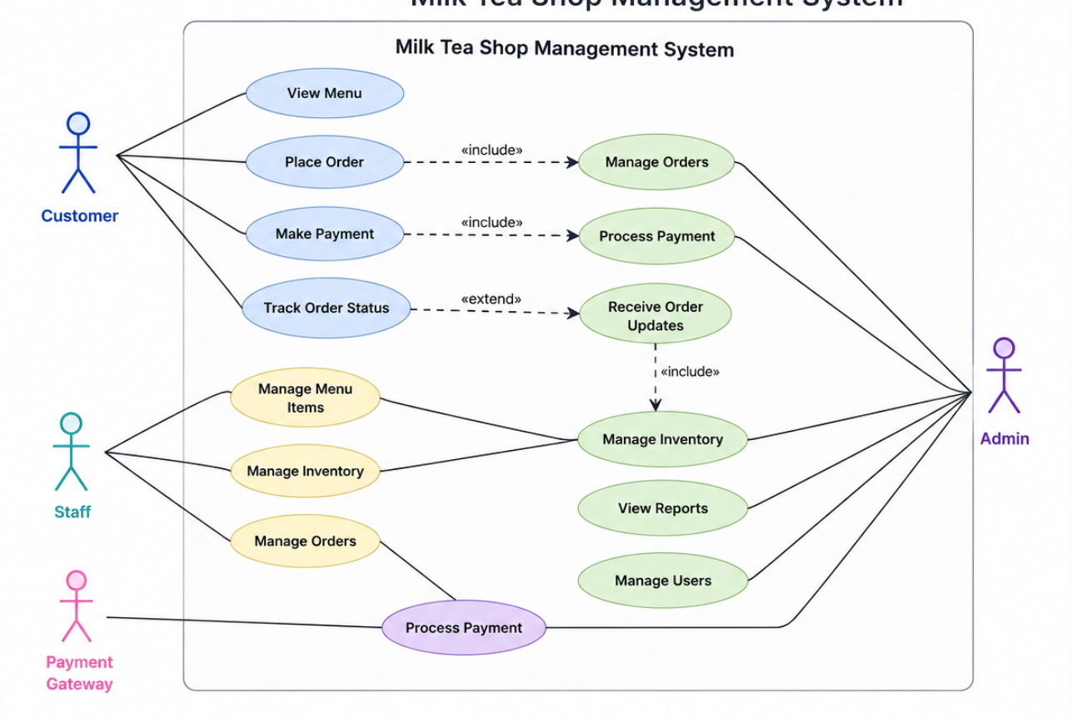

ERD Diagram

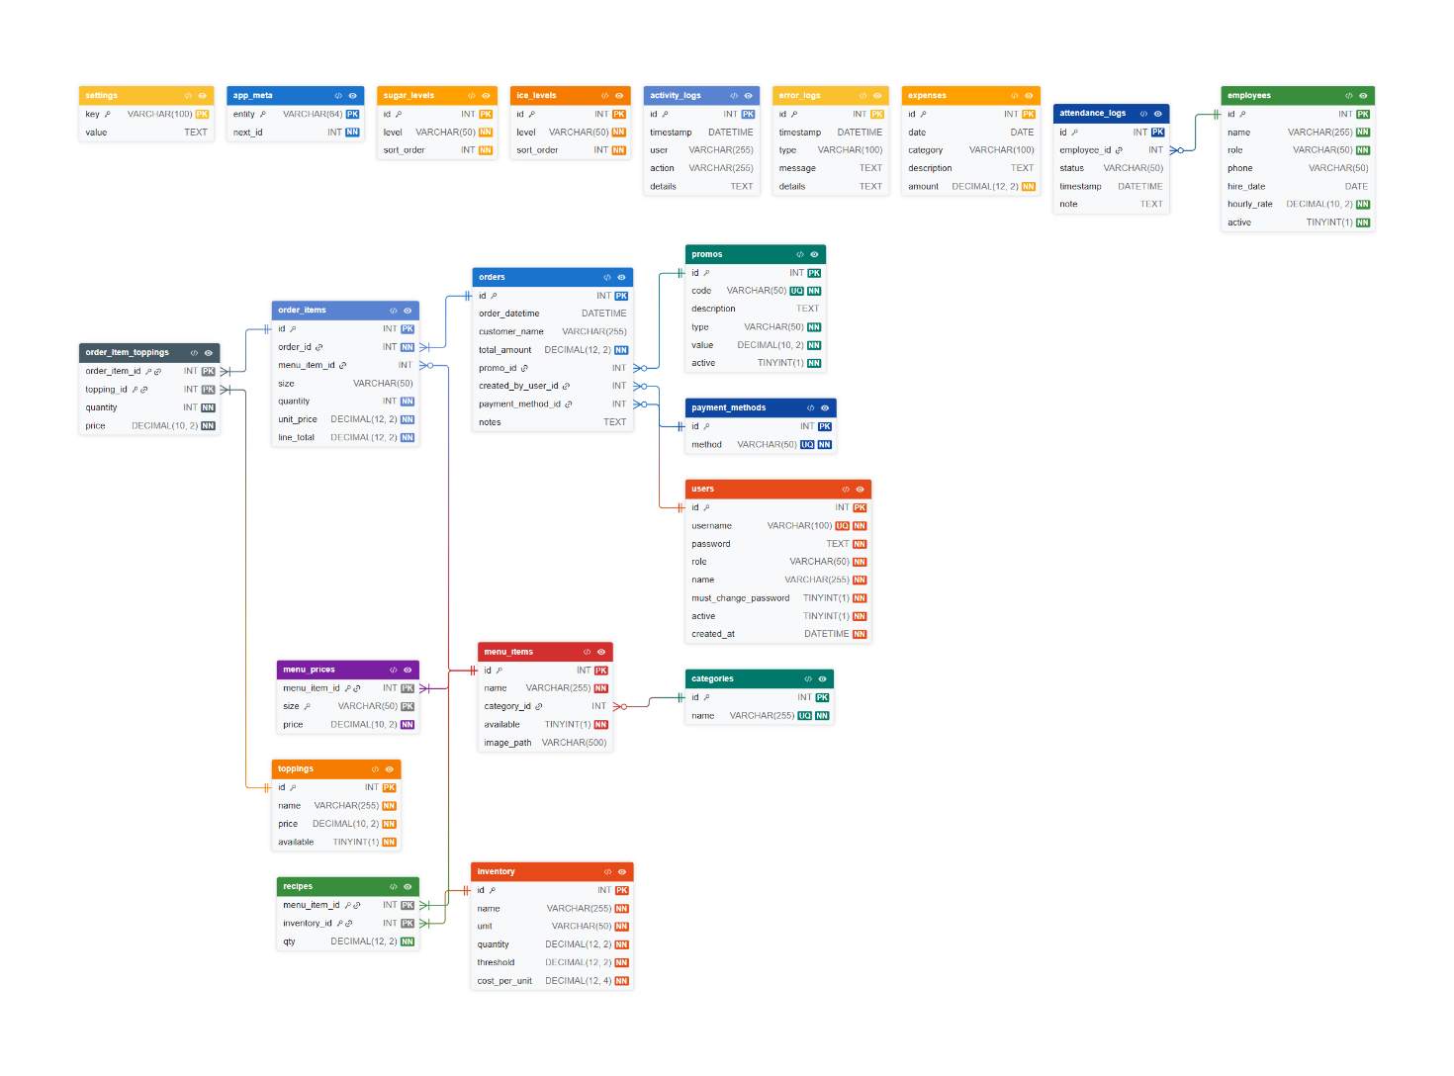

Flowchart
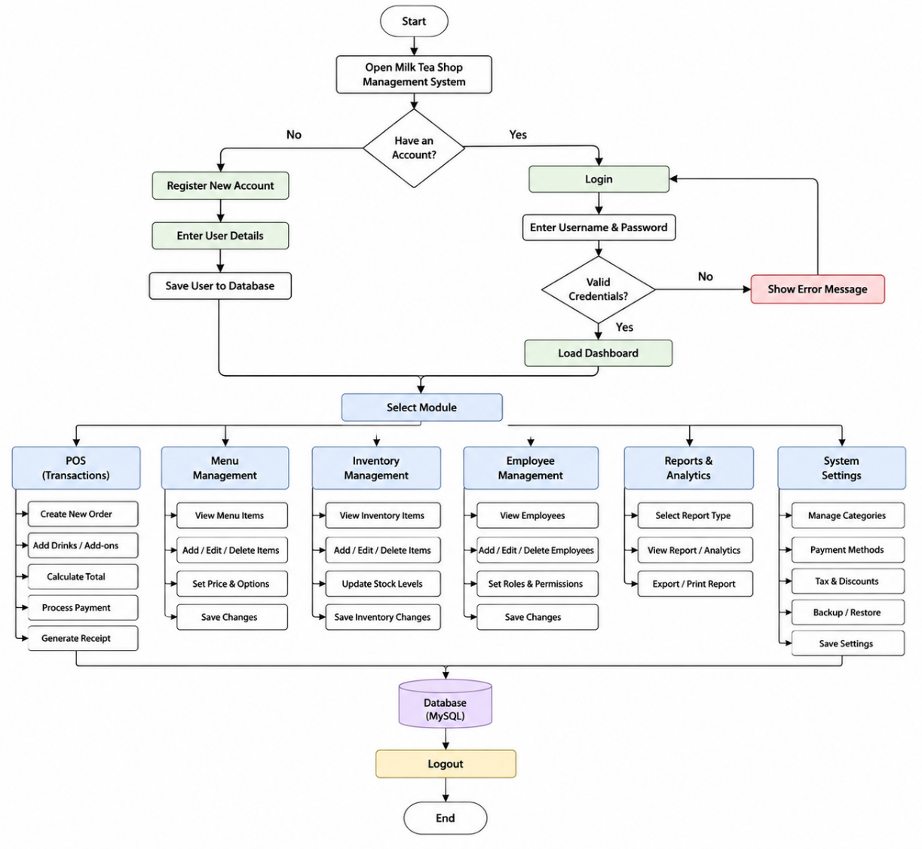

5.1 Tables Used

The database schema (milktea_mysql_schema.sql) defines the following core tables:
Table Name | Purpose
app_meta | Stores the next available primary-key value for each entity to prevent ID collisions.
categories | Lookup table for drink categories (Milk Tea, Fruit Tea, Coffee, Special).
sugar_levels / ice_levels | Lookup tables for customisation options presented to customers at POS.
settings | Key-value store for shop configuration (name, tagline, address, logo path).
users | System accounts with hashed passwords, roles, and active/inactive status.
inventory | Ingredient stock with quantity, alert threshold, and cost per unit.
employees | Staff records with role, contact details, hire date, and hourly rate.
toppings | Add-on items (e.g., tapioca pearls) with individual prices.
promos | Discount codes with type (percent / fixed) and value.
payment_methods | Distinct payment methods referenced by orders.
menu_items / menu_prices | Drink items with per-size prices stored in a child table.
recipes | Ingredient quantities required per menu item, used for auto-deduction.
expenses | Operational expense records (category, description, amount, date).
attendance_logs | Employee Time In / Time Out events with optional notes.
orders / order_items / order_item_toppings | Normalised order data from header to line item to topping detail.
activity_logs / error_logs | Append-only audit trail for user actions and system errors.

  - Data Preparation – Views

The following views were created to simplify complex joins required by the application:
- vw_active_menu_items – Joins menu_items, categories, and menu_prices to expose a flat read-only representation of every drink with its size and price.
- vw_order_summary – Aggregates order header data with promo code, creator name, payment method, and item count for the order history screen.
- vw_low_stock_items – Filters inventory to items at or below their threshold, computing deficit and stock value.
- vw_daily_sales_summary – Aggregates daily revenue, order count, items sold, and promo usage for the Reports dashboard.
- vw_menu_item_revenue – Lifetime revenue and units sold per menu item, used for top-sellers analysis.
- vw_employee_attendance_summary – Counts Time In / Time Out events and shows last attendance per active employee.
- vw_promo_usage – Shows how many orders used each promo code and the total revenue associated.
- vw_order_detail – Flat view of every order line including topping names, used for receipt printing.

  - Stored Procedures

- sp_restock_inventory(p_inventory_id, p_qty_added, p_done_by) – Adds the specified quantity to an inventory item inside a transaction and inserts a matching activity_logs entry.
- sp_get_sales_report(p_date_from, p_date_to) – Returns a day-by-day summary of orders, items sold, total revenue, average order value, and promo order count.
- sp_get_top_menu_items(p_date_from, p_date_to, p_limit) – Returns the top N menu items by quantity sold in a date range, with total revenue per item.

  - Functions

- fn_apply_promo(subtotal, promo_code_in) – Applies a percent or fixed discount to a subtotal and returns the reduced total, or the original amount if the promo is inactive.
- fn_employee_hours_worked(emp_id_in, date_from, date_to) – Counts the number of distinct days an employee logged a Time In within a date range.
- fn_inventory_value() – Returns the total monetary value of all current stock (SUM of quantity × cost_per_unit).
- fn_daily_revenue(target_date) – Returns the sum of total_amount from all orders placed on a given date.

  - Triggers

- trg_after_order_insert – Fires after a new row is inserted into orders. It joins order_items with recipes and performs a single UPDATE on inventory to deduct the aggregate ingredient usage for all items in that order, flooring the quantity at zero.
- trg_before_order_item_insert – Fires before an order_items row is inserted and raises a SIGNAL if the referenced menu item is unavailable, preventing ghost line items from entering the database.
- trg_after_employee_insert – Inserts a welcome activity_logs record automatically whenever a new employee row is created.
- trg_after_expense_insert – Logs each new expense into activity_logs with category, description, and amount for the audit trail.

- Screenshots

The screenshots below illustrate the main features of the Brewster’s Cup Management System. Each section of the application is accessible via the sidebar navigation and is rendered conditionally based on the logged-in user’s role.

Login Screen
Users authenticate using their username and password. The admin account is created automatically on first startup. Upon successful login, the user is directed to the Dashboard.

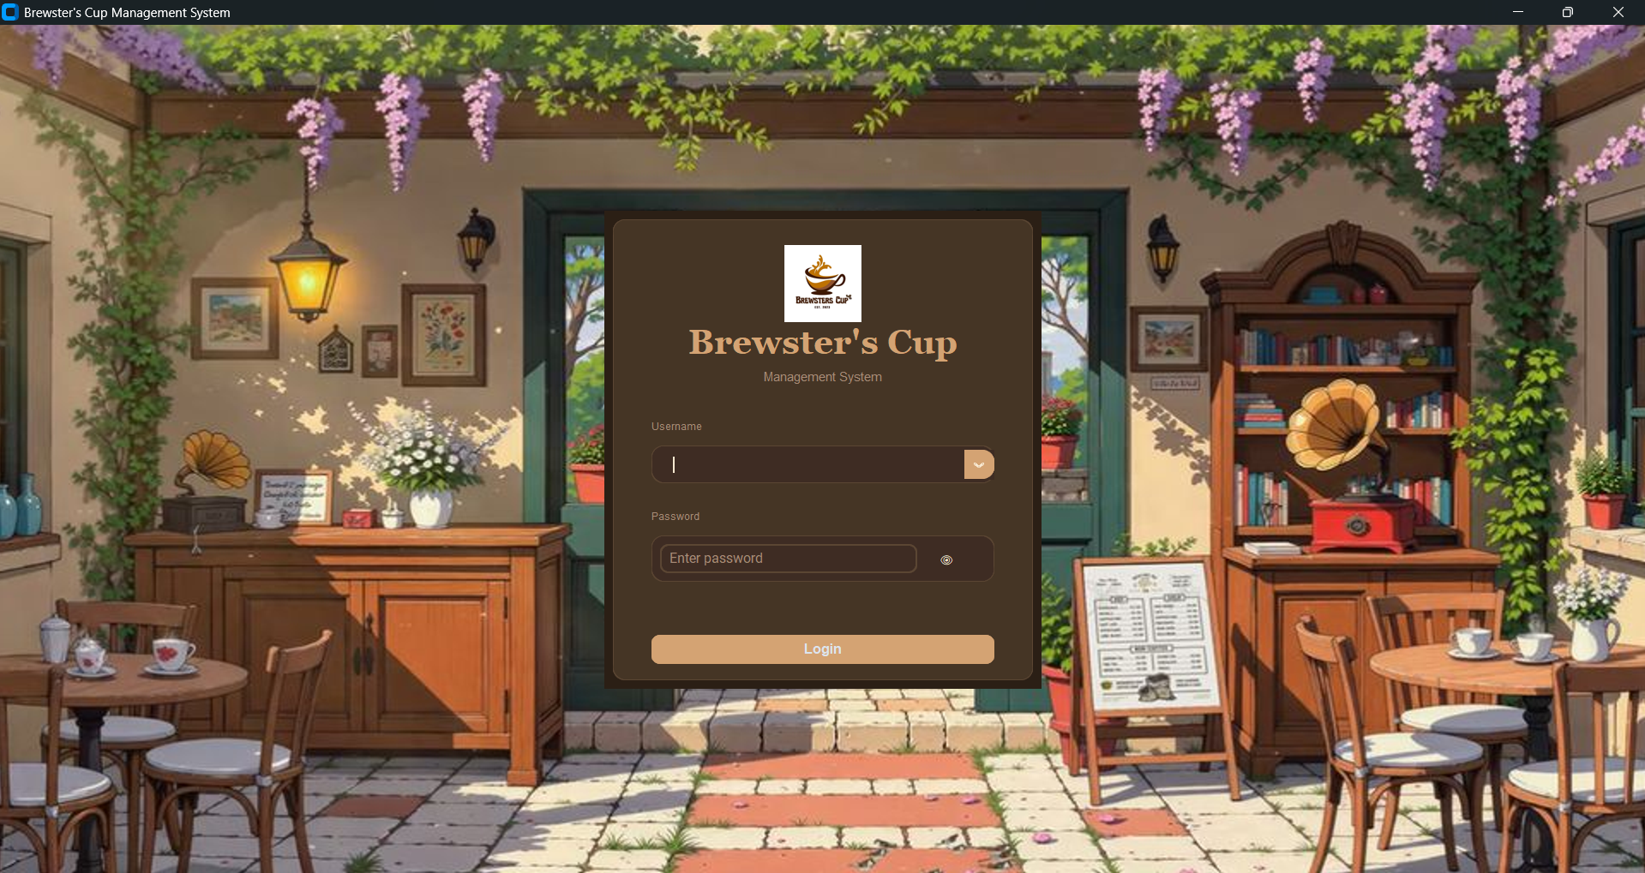

Dashboard
The Dashboard displays today’s sales total, number of orders, top-selling items, and low-stock inventory alerts in a card-based layout. It serves as the landing page for all roles.

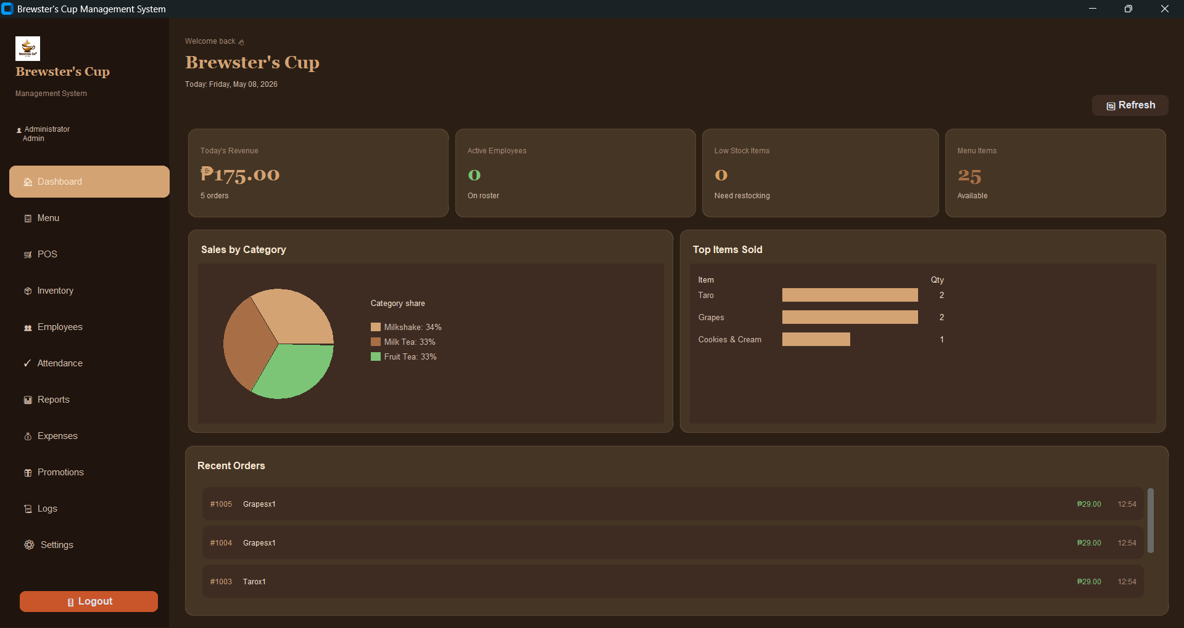

Menu Management
The Menu section allows admins to add, edit, and toggle the availability of menu items. Each item supports multiple size-price tiers and a linked recipe that specifies which inventory ingredients and quantities are consumed per order. Menu items can be associated with uploaded product images.

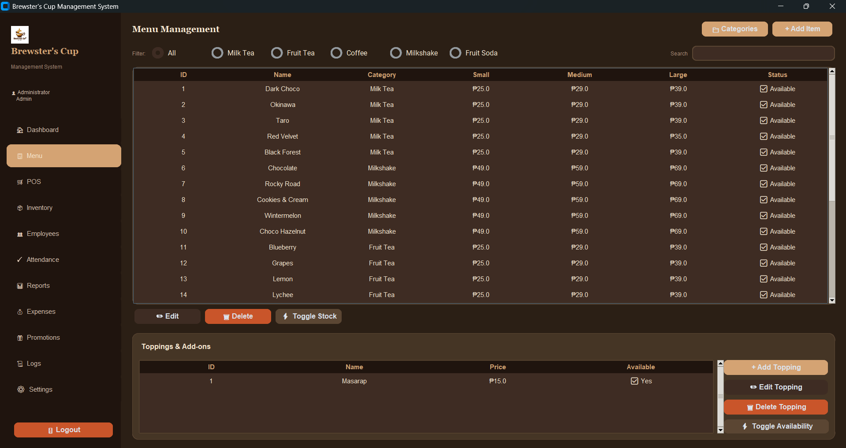

Point-of-Sale (POS)
Cashiers select drinks from the menu, choose size, sugar level, ice level, and toppings, add items to the cart, apply a promo code, select a payment method, and complete checkout. A receipt can be printed or saved as CSV.

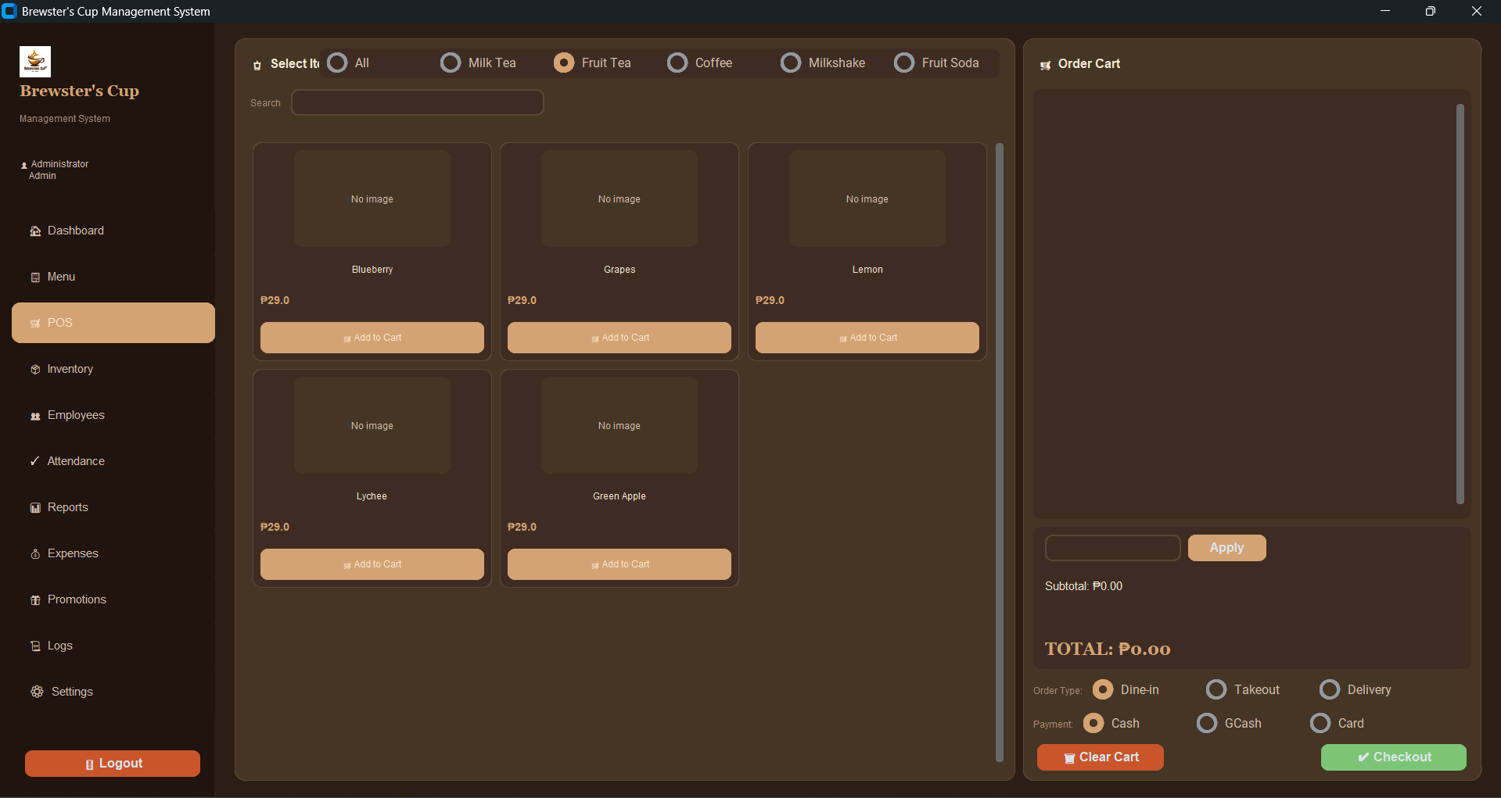

Inventory
Managers can view all ingredients, their current stock levels, cost per unit, and alert thresholds. Low-stock items are highlighted. Stock can be restocked via a dialog that calls sp_restock_inventory internally.

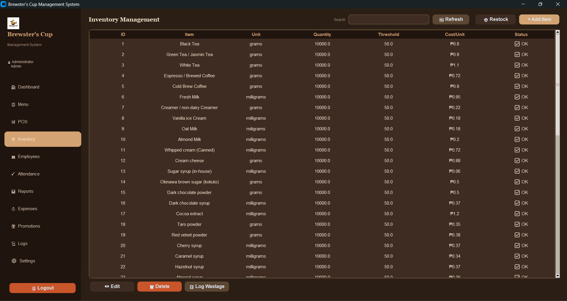

Employee and Attendance Management
The Employees section maintains the staff roster with roles, contact details, hire dates, and hourly rates. The Attendance module allows staff to log their daily status (Present, Absent, Late, Leave), which is persisted to attendance_logs. The section computes hours worked and estimated wages for payroll purposes.

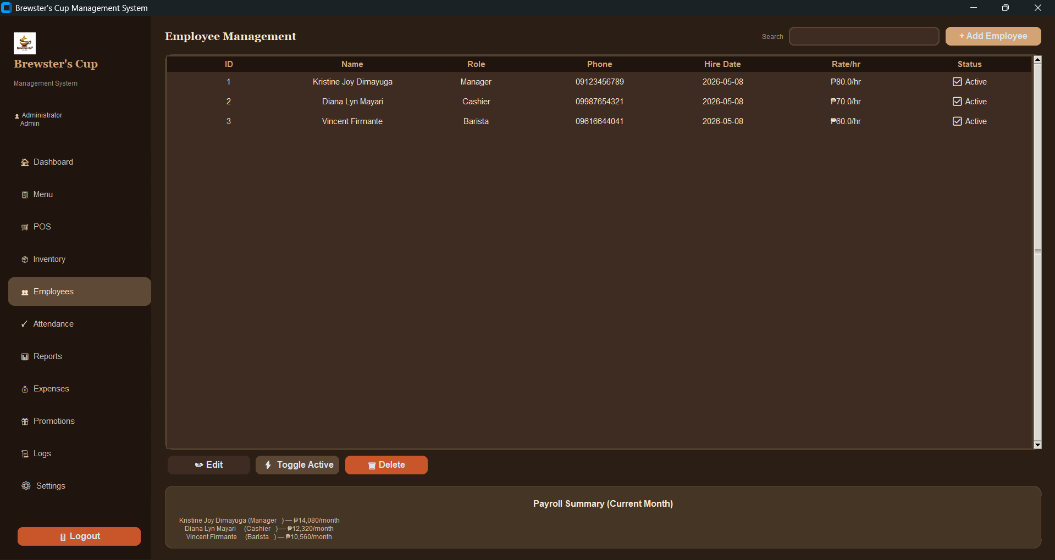

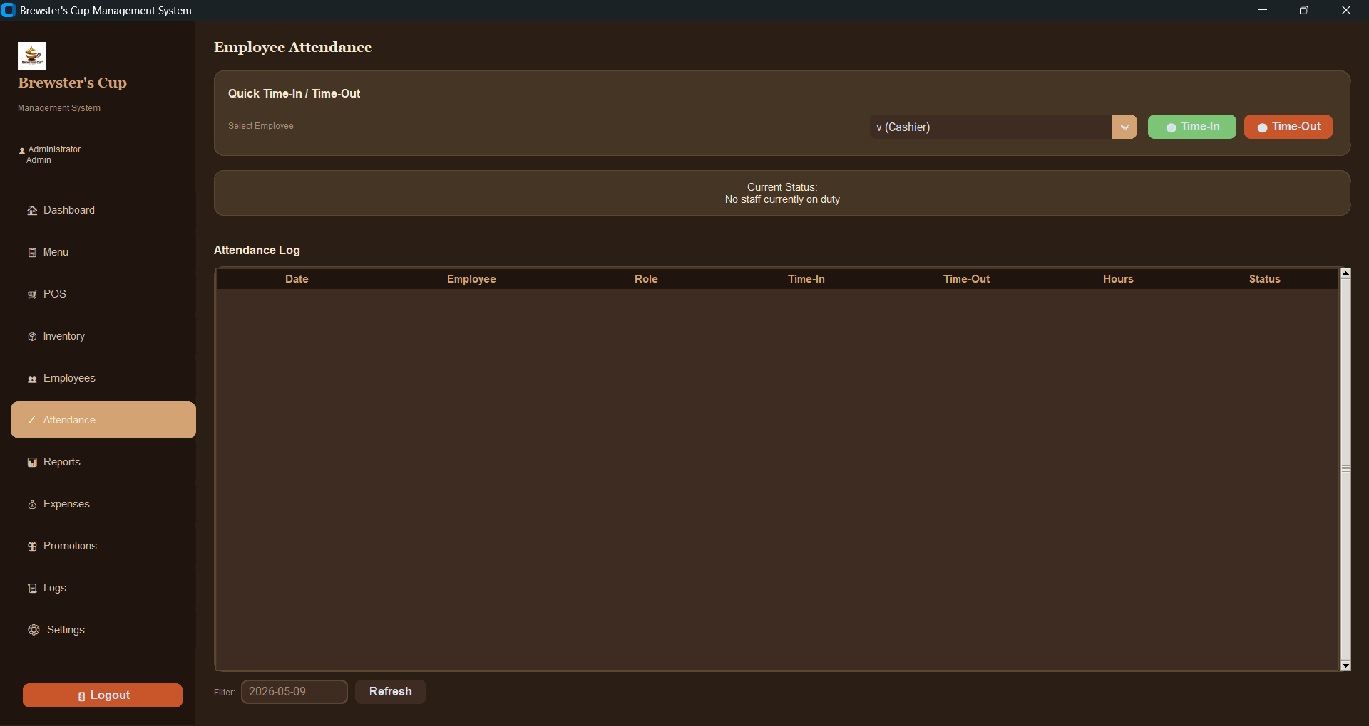

Reports
The Reports section provides date-range sales summaries, top menu items by revenue, daily totals, and expense breakdowns. Data is queried from vw_daily_sales_summary and vw_menu_item_revenue.

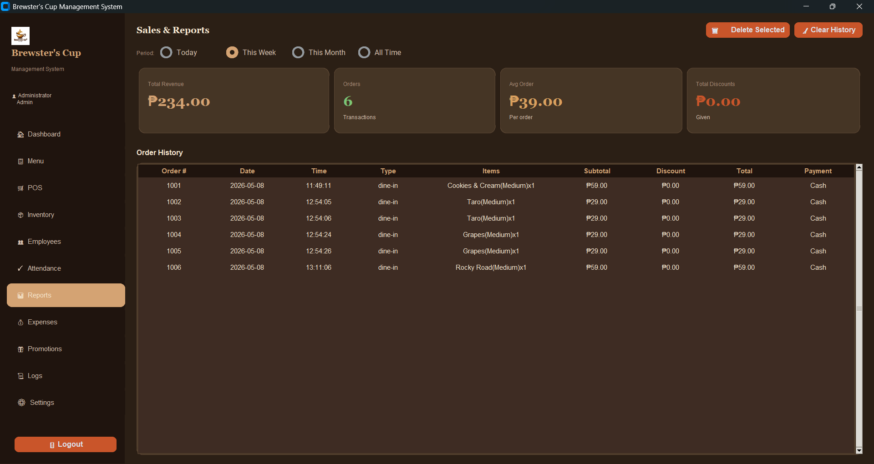

Logs
The Logs section exposes the activity_logs and error_logs tables, allowing Admins to audit every login, order placement, inventory update, and system error with timestamps and user attribution.

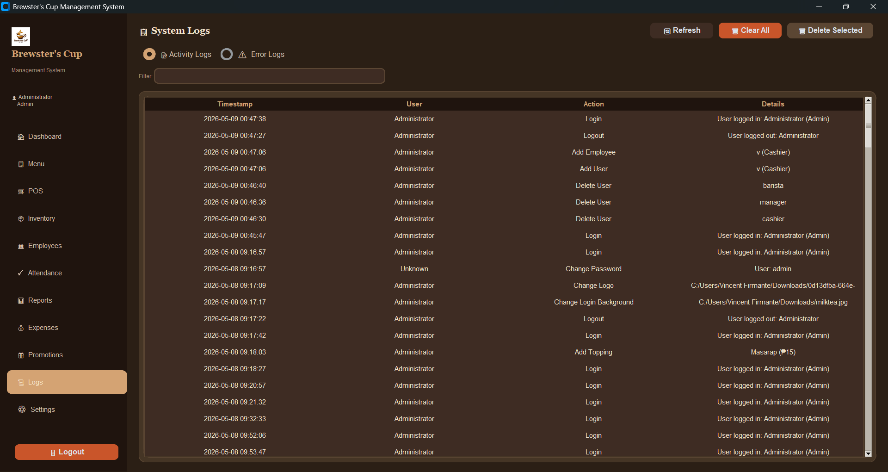

Settings
The Settings panel (Admin-only) allows configuration of the shop name, tagline, logo path, and other system-wide preferences. Changes are persisted to the settings table and reflected immediately across the application through the update_branding() method.

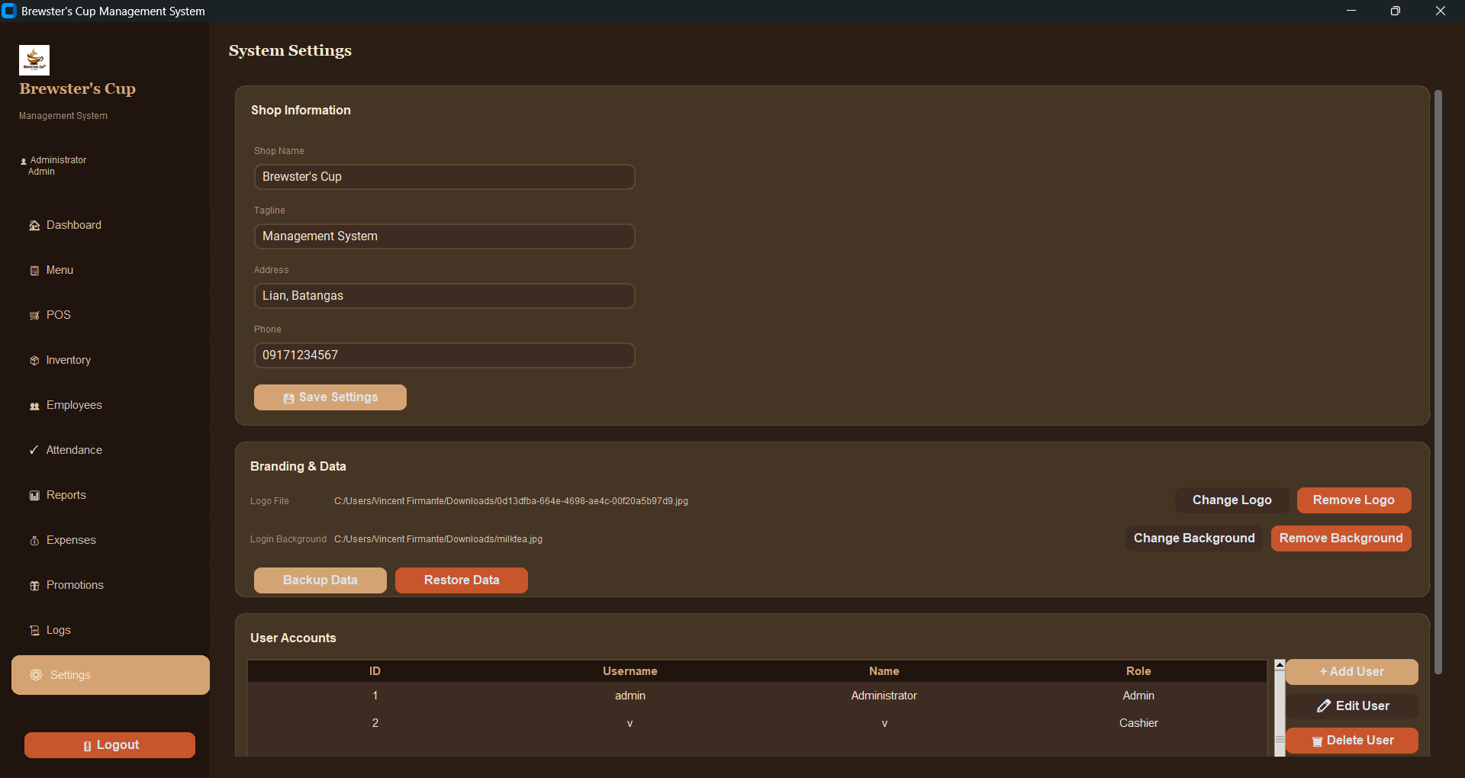

- Insights

FIRMANTE: Database management systems play a transformative role for small and medium enterprises today. By storing all operational data in a structured, relational schema, Brewster’s Cup gains a single source of truth that eliminates the reconciliation burden of siloed spreadsheets. The use of foreign-key relationships ensures referential integrity, an order can only reference a valid menu item, and an attendance log can only point to a known employee, which prevents the class of data corruption errors that are common in manual systems.

DIMAYUGA: Triggers and stored procedures push business logic closer to the data layer, making it reusable regardless of which application or tool accesses the database. Automatic inventory deduction via trg_after_order_insert means that stock levels are always accurate even if the application crashes mid-order, since the trigger executes as part of the INSERT transaction.

MAYARI: Views provide query abstraction, so the Python application layer can issue simple SELECT statements against pre-joined views rather than constructing complex multi-table queries, reducing both development effort and the risk of query errors. Together, these features demonstrate how a well-designed DBMS enables a small business to operate with the data discipline previously available only to large enterprises.

- Challenges and Learnings

Challenges Encountered

We encountered several challenges during the development of the system. One of the main difficulties was connecting the attendance system to the database. We also experienced issues when updating the database whenever changes were made in the user interface.

At first, we tried using PyQt5, but we found it difficult to work with, so we decided to use CustomTkinter instead. Another challenge was editing and updating the data in the database because we often encountered errors. Due to these issues, we sometimes had to drop the database and recreate it to fix the problems.

Lessons Learned and Future Improvements

Through these challenges, we learned the importance of properly planning the database structure before connecting it to the system. We realized that changes in the user interface can affect how data is stored and updated, so it is important to make sure that the database and the UI work together correctly. We also learned that testing each feature step by step can help us identify errors more easily.

We also gained more knowledge about choosing the right tools for our project. Since PyQt5 was difficult for us to use, we learned to adapt by using CustomTkinter, which was easier to understand and apply. This experience taught us to be patient when solving errors, especially when editing and updating data in the database. It also helped us improve our problem-solving skills and teamwork during the development process.

- SQL Query Statement used

The following representative SQL statements are used throughout the application:

INSERT with ON DUPLICATE KEY UPDATE (Upsert)

INSERT INTO inventory (id, name, unit, quantity, threshold, cost_per_unit)
VALUES (%s, %s, %s, %s, %s, %s)
ON DUPLICATE KEY UPDATE
name=VALUES(name), unit=VALUES(unit), quantity=VALUES(quantity),
threshold=VALUES(threshold), cost_per_unit=VALUES(cost_per_unit);

SELECT with JOIN – Load Orders

SELECT o.*, p.code AS promo_code, u.name AS created_by,
pm.method AS payment_method
FROM orders o
LEFT JOIN promos p ON p.id = o.promo_id
LEFT JOIN users u ON u.id = o.created_by_user_id
LEFT JOIN payment_methods pm ON pm.id = o.payment_method_id
ORDER BY o.order_datetime DESC;

DELETE Orphaned Records

DELETE FROM order_item_toppings
WHERE order_item_id IN (
SELECT id FROM order_items WHERE order_id = %s
);
DELETE FROM order_items WHERE order_id = %s;
DELETE FROM orders WHERE id = %s;

Trigger – Auto-Deduct Inventory After Order Insert

CREATE TRIGGER trg_after_order_insert
AFTER INSERT ON orders
FOR EACH ROW
BEGIN
UPDATE inventory inv
JOIN (
SELECT r.inventory_id,
SUM(r.qty * oi.quantity) AS total_used
FROM order_items oi
JOIN recipes r ON r.menu_item_id = oi.menu_item_id
WHERE oi.order_id = NEW.id
GROUP BY r.inventory_id
) deductions ON deductions.inventory_id = inv.id
SET inv.quantity = GREATEST(inv.quantity - deductions.total_used, 0);
END$$

Stored Procedure – Sales Report

CALL sp_get_sales_report('2025-01-01', '2025-01-31');
Returns: sale_date, total_orders, total_items_sold, total_revenue, avg_order_value, promo_orders

Function – Apply Promo Discount

SELECT fn_apply_promo(250.00, 'SAVE20') AS discounted_total;
Returns: 200.00 (20% off a PHP 250 subtotal)

View Query – Low Stock Items

SELECT * FROM vw_low_stock_items;
Returns: id, name, unit, quantity, threshold, cost_per_unit, stock_value, deficit

View Query – Top Menu Items by Revenue

CALL sp_get_top_menu_items('2025-01-01', '2025-12-31', 5);
Returns: id, item_name, category, total_qty_sold, total_revenue

